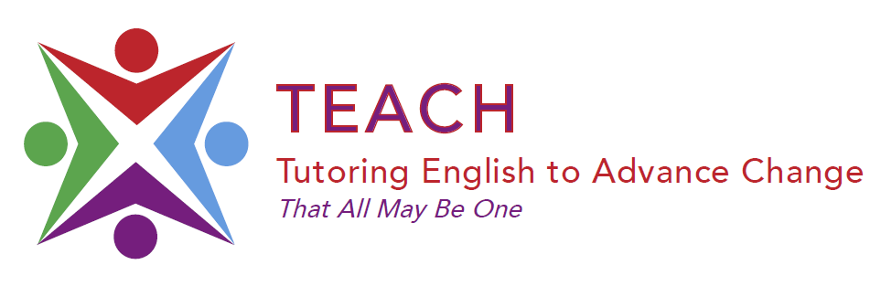
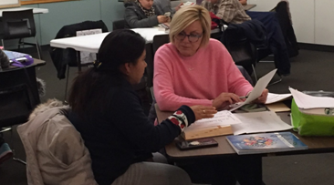
We are looking for volunteers to teach English as a Second Language to adults.

TUTORS are NEEDED at all locations!
Addison/Berwyn/Brookfield/Cicero/Summit
Downers Grove/ West Chicago /Woodridge
Call for information about our next
FREE Tutor Training Session!

Tutors meet with students for 1 hour one time per week.

No special experience required. We will train you!

For more information, please call or text:
Susana Aguilar 630-217-0396
Cathy McCabe 630-248-9594

Check us out online: www.teachempowers.org!

sponsored ministry of the Congregation of St. Joseph

